Evidence Output

T010:

Valid first name case.

Input 123 in first name case

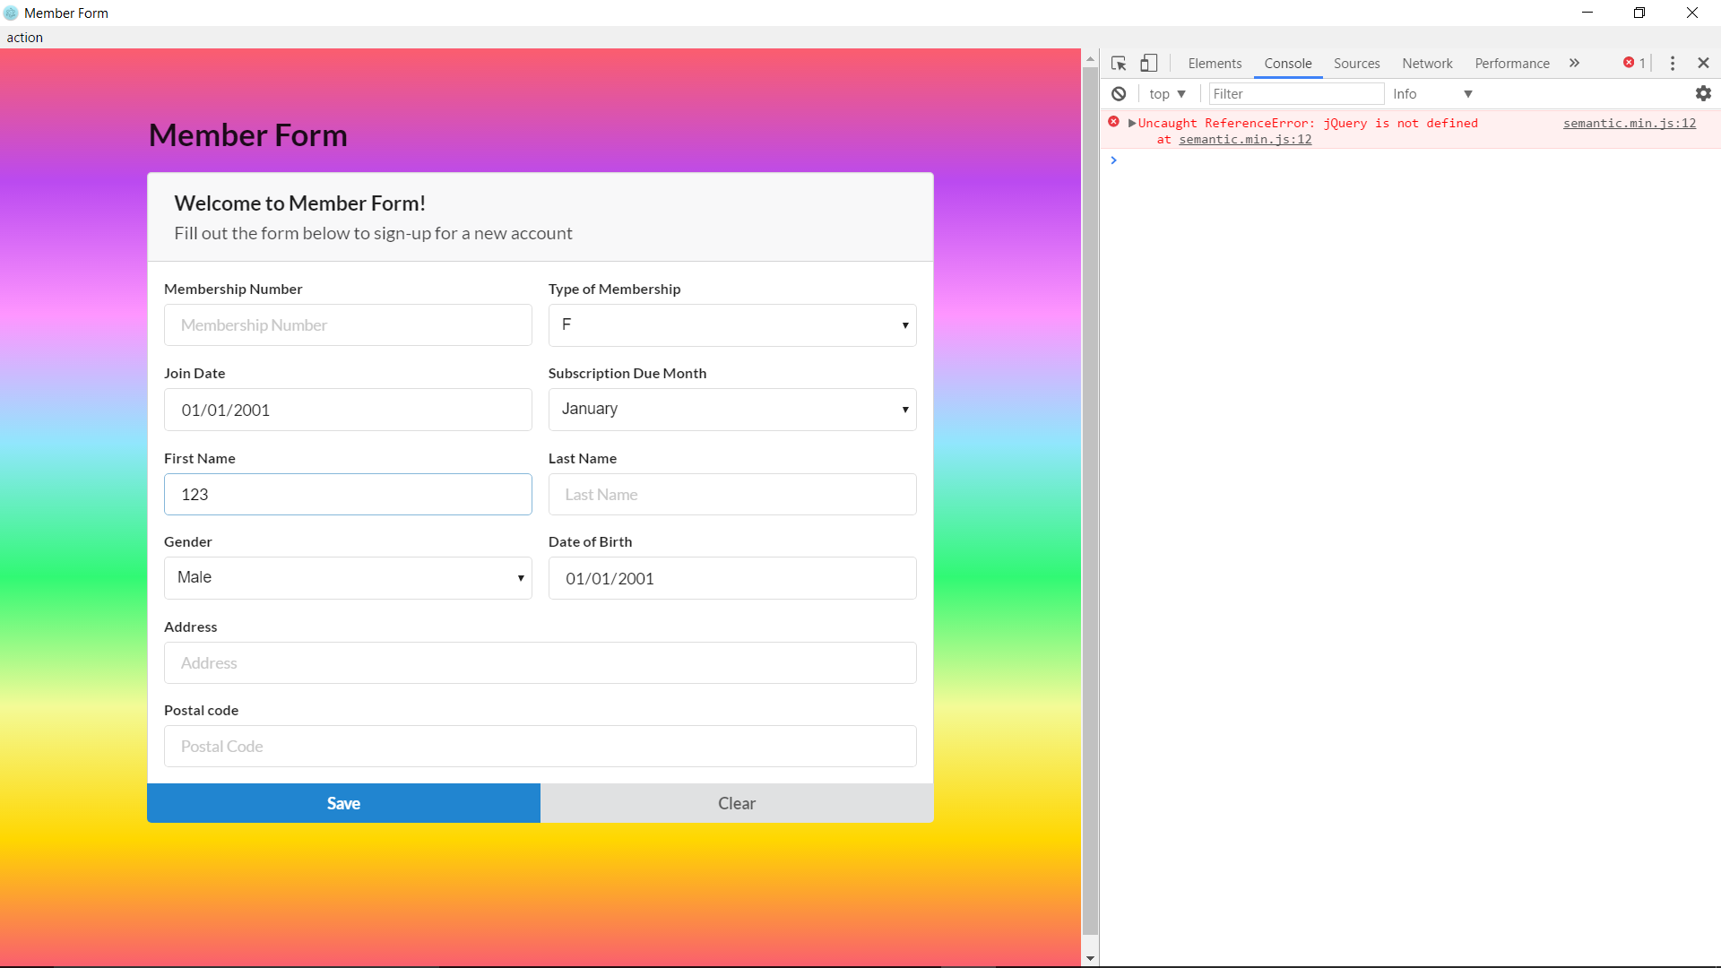

First name case valid fail.

